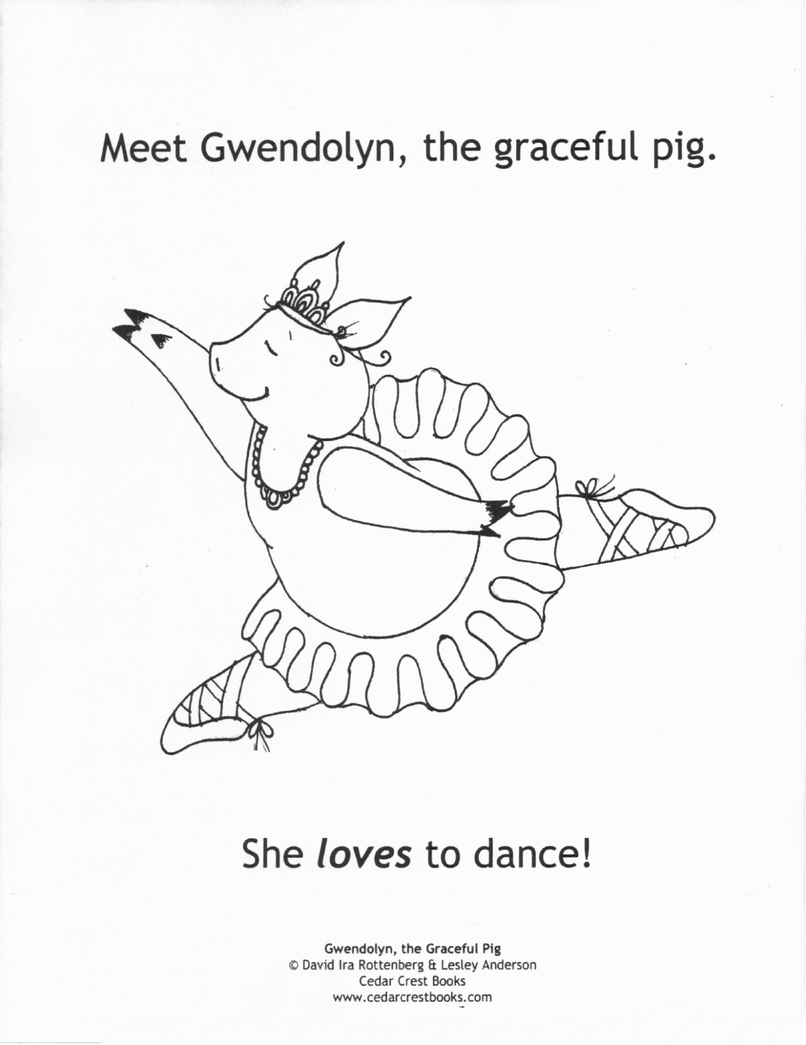
Dancers from the InMotion Performing Arts Center join author, David Ira Rottenberg, on Wednesday, February 22nd at the Feinberg-Fisher K-8 Center for a special reading and dance performance
of Gwendolyn, the Graceful Pig.

